Muhammad Umar Farooq
Writing task 1

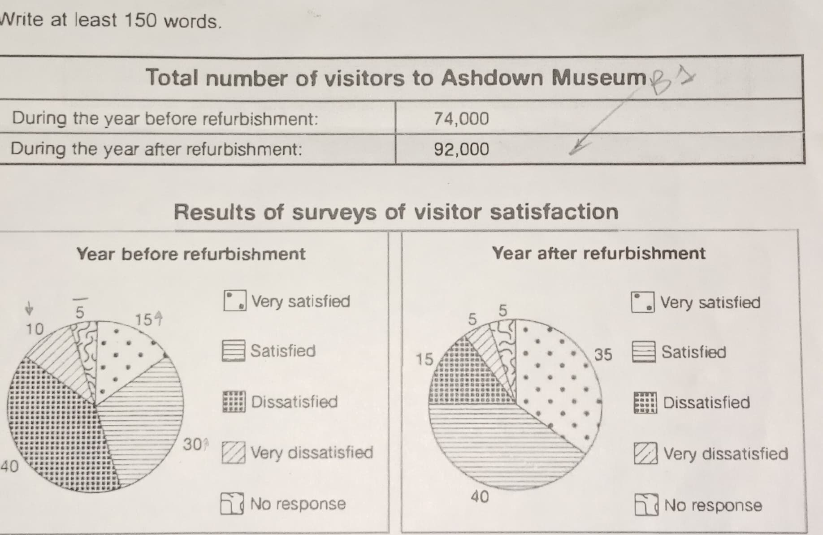
The table illustrates the number of visitors to Ashdown Museum before and after renovation throughout the year. While two charts demonstrate the survey feedback on how visitor were gratified while enjoying the museum in both time periods.

Overall, the number of visitors increased after the museum’s renovation, people were pleased with the updates and expressed their positive feedback over the period.

Looking at the details, the table showed the impact of modernization on the tourists. Before the upgrade, the number of visitors was 74,000 and, it rose to 92,000 during the year.
Moving on to the specifics, before the renovation, 10% of attendees were very dissatisfied with the museum however, after refurbishment it decreased by 5% which points improvement over the year. 40% expressed dissatisfaction but it decreased by 30% during the time frame. Meanwhile, 5% community did not have an opinion in both cases.
Surprisingly, earlier than the upgradation 15% visitors were very satisfied by the museum, defiantly it rose to 20% after the reconditioning. 30% papulation had the likeliness attitude earlier and improved to 40% over the year.

